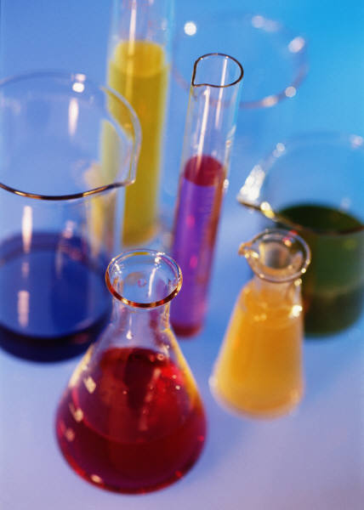
Dear (Student),
I'm excited that you'll be in my 7th grade Health and Science class this year! I've got some exciting things planned for our class. We'll be exploring Matter, Earth Systems, Cells, and Classification. Aside from our classwork, we will be working in the laboratory and engaging in various exploration activities.
In addition, the 7th grade science team will be offering fun extension activities during Real Time. These activities include Forensics, Electricity, and Rocketry to name a few.
Enjoy the last few weeks of summer and come prepared and ready for a great year!
Ms. Anderson

